Supporting mental health and wellbeing after disaster
- Some framing:
International best practice – Interagency Standing Committee (Note – apply in a culturally appropriate way).
Framing support this way helps not to pathologize normal responses – and provides room and validity for programs at all levels (including those who will not need specialist support but will benefit from connecting with others, having spaces to reflect and talk, having responses normalized, having strengths and positive coping strategies recognized and reinforced).
What is being provided at each level? How can we support those providing services at each level currently? Where are the gaps? What is needed?
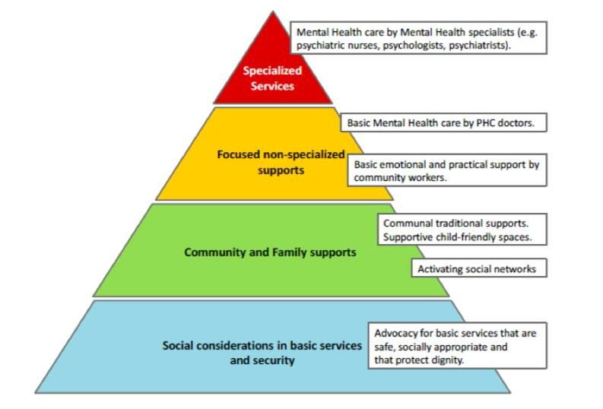
Australia’s National Disaster Mental Health and Wellbeing framework is helpful for grant writing – looking for best practice principles and the evidence base. The following table shows how these key priorities are put into action.
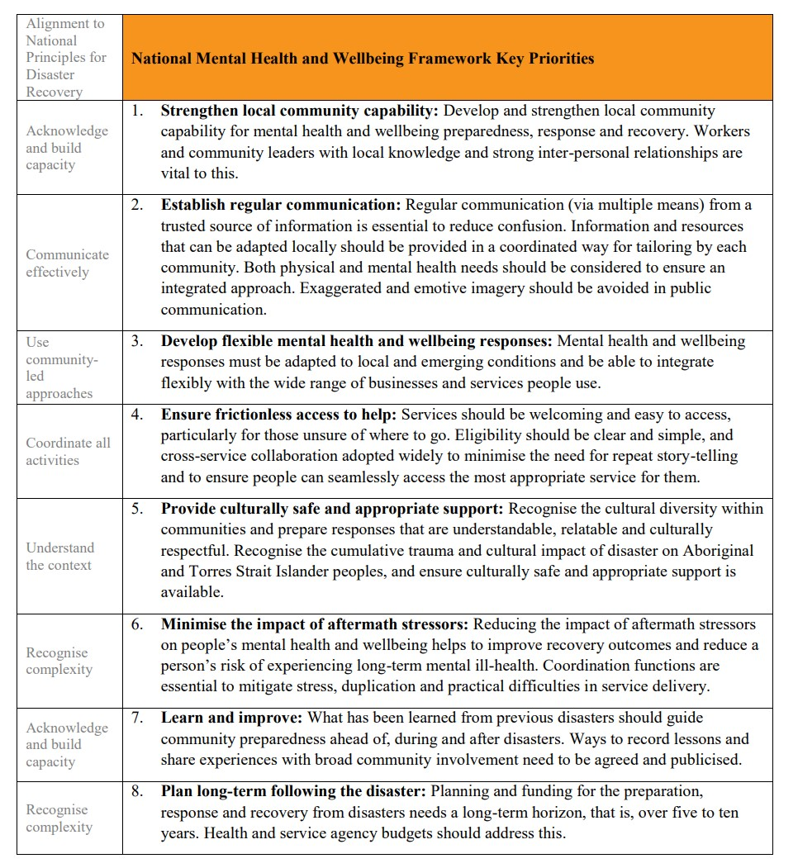
Tool to guide selection of school-based post-disaster psychosocial interventions

- Programs implemented in Christchurch that could be adapted or used for inspiration/learning if useful:
- Support for those who lost loved ones – bereaved support program
- All Right? Campaign – messaging for the general public to normalize responses, encourage connection and conversation and promote evidence-based coping strategies. Created to reflect local wording, concerns, strategies and considerations… A guide to the process underpinning the All Right? Campaign. A guide for public messaging campaigns here if helpful (refer to the first guide in first instance as most relevant).
- Indigenous response – learning that may be helpful to other indigenous communities after disaster
- Adaption of World Health Organization’s Psychological First Aid framework - an indigenous model. Marae-based training
- Outreach – volunteer-based provision of support to those impacted (a team of 100). (Care, connection, the opportunity to talk and be heard (if wanted), normalizing responses, strength-based approach, information provision, linking with services. Involved volunteer training, volunteer support and supervision processes, risk management, referral pathways etc
- Appeal/cash grant design and management. Our grants covered everything from an initial emergency grant to support for those with disabilities, to the bereaved, to water reconnection, independent advice etc. evaluation report. I can also track down (if helpful) a learning document – guidelines for cash grant development.
- Wellbeing survey (+ paper ) – tracking population wellbeing as a measure of recovery and to inform decision-making
- Bounce – youth campaign – messaging and events for young people, by young people. Engaging and empowering young people to be involved in the recovery process. Lots of learning here (what went well, what didn’t)
- School Children’s grant program – channeling support to children through grants to schools who can then elect to pay for counsellors, events, alleviate financial hardship etc depending on the needs of their children and school community
- Student Volunteer Army – students who came together to support their communities. Emerging leaders and incredible impact.
- Community education – recovery basics: Education sessions about what’s normal to expect and experience and what’s helpful… Common patterns, trajectories, challenges and helpful strategies. We also videoed these and created short videos that communities found really useful
- Men – I’m less able to talk on this but we approached this by funding, supporting, speaking at local men’s groups and events such as Men’s Sheds.
- Creating community spaces after disaster – Gap Filler. Incredibly creative, community-driven emergent group who created temporary spaces that brought joy, connection and healing while waiting for the official rebuild to happen.

- Other useful resources:
- After the disaster podcast
- Communicating in recovery – a guide
- Collective trauma best practice guidelines
- Temporary memorials – a guide

